Government Engineering College, Thrissur
CS333– Application Software Development Lab
Documentation -
Exp 4 – Constraints and Views
Exp 7 - Creation of Views and Assertions

Date of Submission
22 September 2020

Submitted By
Kowsik Nandagopan D
Roll No 31
TCR18CS031
GECT CSE S5

Experiment 4

AIM
Creating a database to set various constraints.

Description
Relations between the database is already created in the Experiment 1 and 2. In this experiment we will be focusing on setting constraints on tables that were created in the previous experiments.
Constraints that are available in MySQL are Use constraints like Not Null, Primary Key, Unique, Foreign Key.
Note: CHECK command is not supported in some MySQL versions

Output / Screenshots
1. Displaying the Constraints set during Table creation
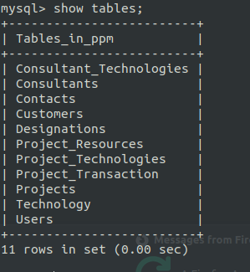

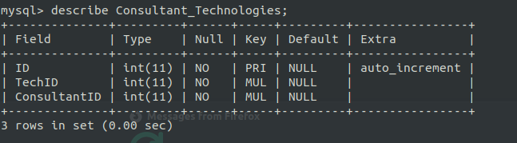
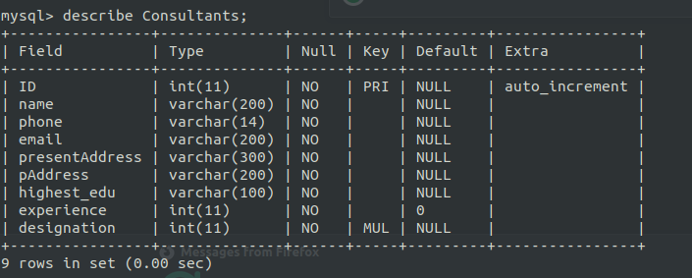
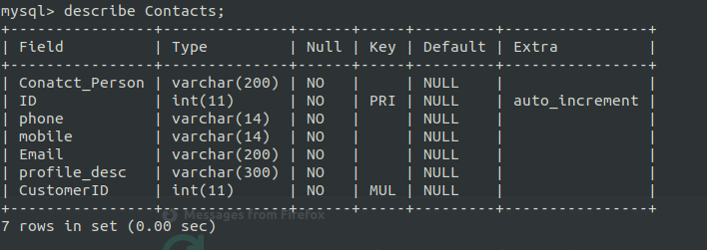
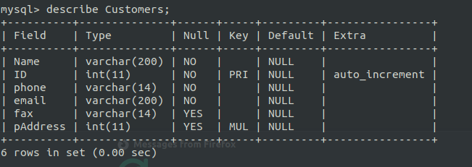
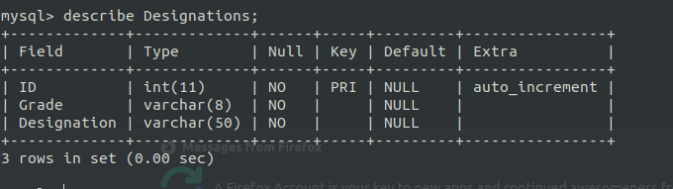
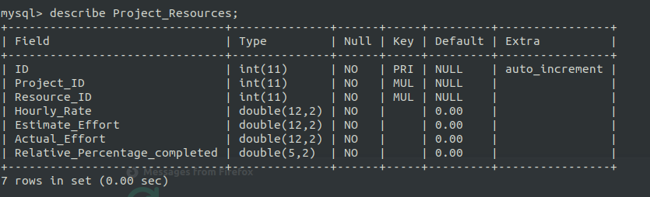
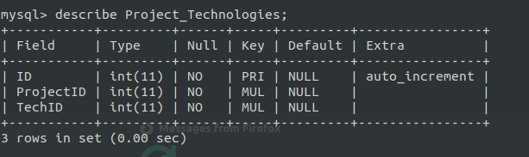
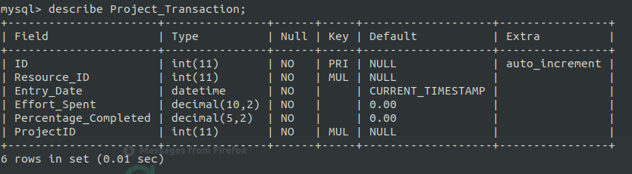
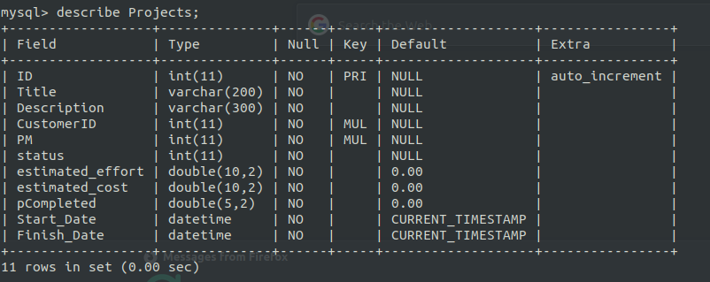
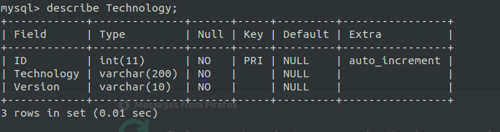
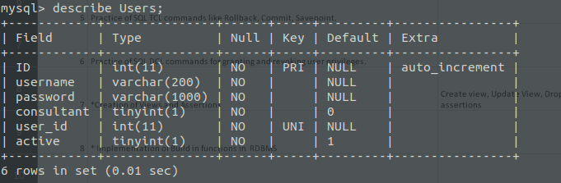
2. Trying to Override the constraints
- Trying to insert into Projects Table with NULL and check whether it produces an error
- Also For estimated_effort | estimated_cost | pCompleted | Start_Date | Finish_Date check whether DEFAULT Constraint works
2.1 NOT NULL
2.2 DEFAULT
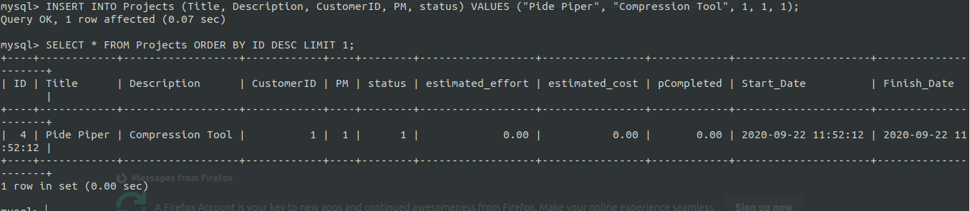
2.3 Trying to add using duplicate PRIMARY KEY
- Try to Insert row into Projects table with duplicate primary key
- Select the last entered row and use it's primary key
2.4 Non Existing FOREIGN KEY
Try to add a Project with non existing FOREIGN KEY (Non exixting Project Manager)

- This will give an error - ERROR 1452 (23000): Cannot add or update a child row: a foreign key constraint fails (`ppm`.`Projects`, CONSTRAINT `Projects_ibfk_2` FOREIGN KEY (`PM`) REFERENCES `Consultants` (`ID`))
- Due to PM (FOREIGN KEY to Consultants Table) does not exist
Correct:
2.5 UNIQUE
Try to override UNIQUE Constraint of user id (FOREIGN KEY) in User Table
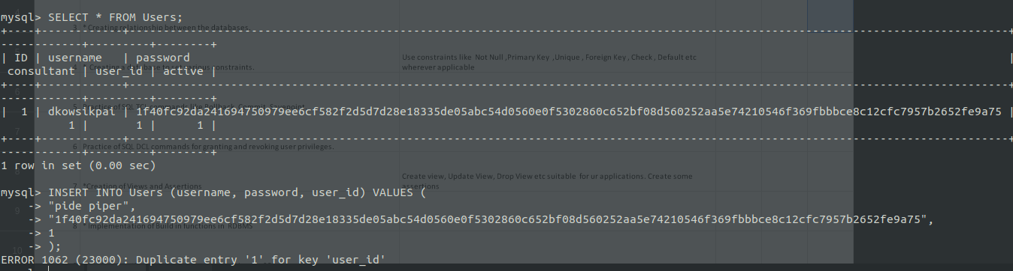
Correct:

Experiment 7

AIM
Creation of Views and Assertions

Description
Relations between the database is already created in the Experiment 1 and 2. In this experiment we will be focusing on setting different views that can be created on relations between table using the CREATE VIEW command in SQL
Note: ASSERTION command is not supported in some MySQL versions

Output / Screenshots
1. Project Technology Table Join View - Technologies used in Project
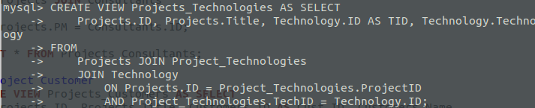
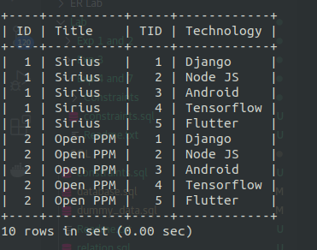

2. Project Consultants - People working in the projects, Project Customer , Displays the relative efforts spent by the consultants on particular project
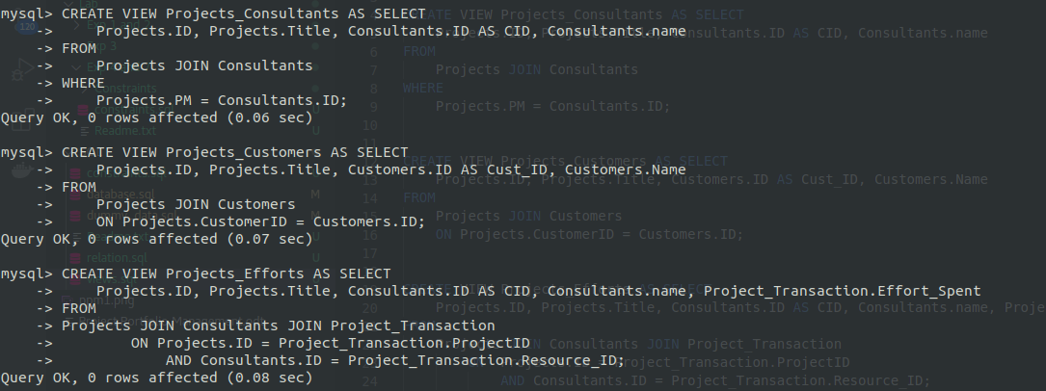
Project - Consultants
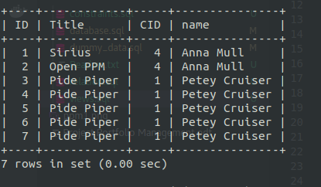

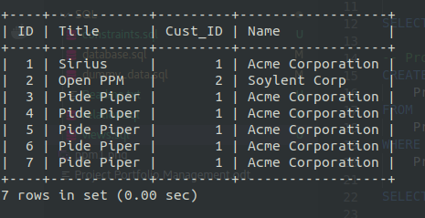
Project - Customer
Project – Effort
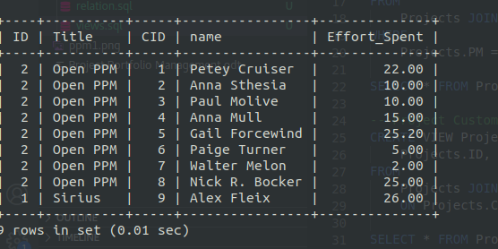
3. Consultant Designation Details
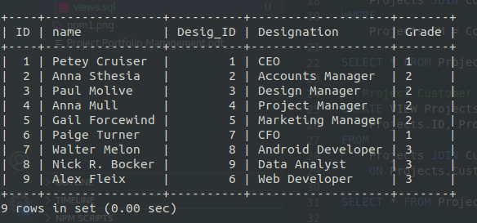
P. T. O

4. Alternate contact Information related to each project
